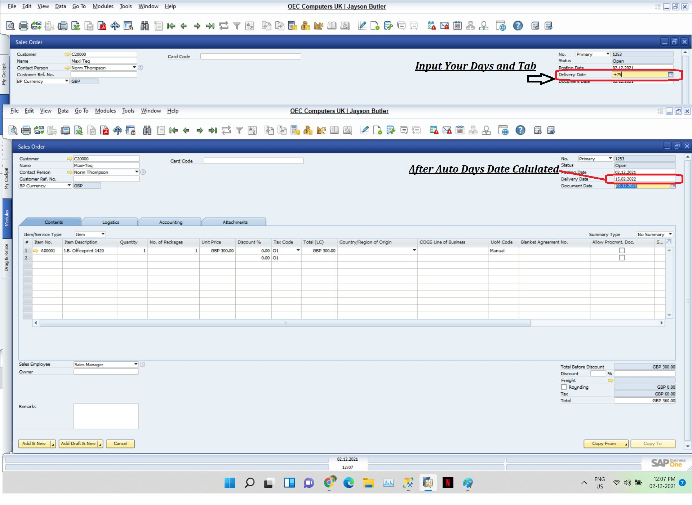
Sometimes it's difficult to calculated Date based from days on any transaction form.
Example if create Sales Order we know that posting date is auto created but sometimes Delivery Date is difference then Order.
Here we can use this Function to calculated Date on behalf of Delivery days Term like Order after 70 days, 100 Days.
When we create Sales order and we know only Days not Date then just input your "+75" and Tab, the result will be with auto Date.

